Read Me for Google Earth

- Run the Program Google Earth
- Click File ---- Open
- Select the kmz file ‘falgrp2.kmz’ and open
- Under Temporary places a folder will appear ‘Falmouth – Group 2’
- All of the Placemarks show vertical location profiles when clicked.
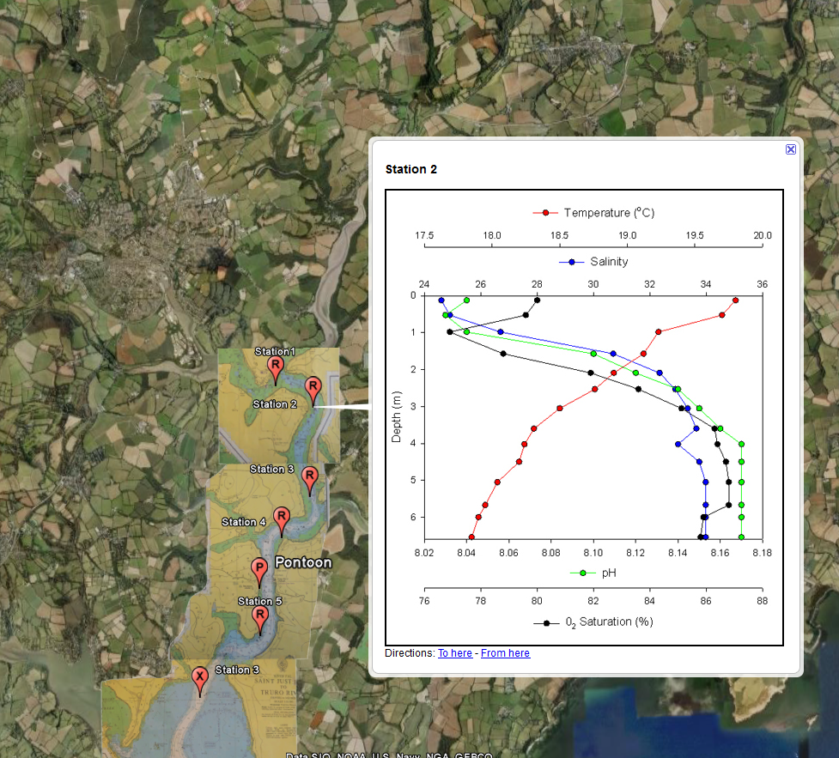

- The admiralty chart can be Faded or removed by selecting it and sliding the bar
- 

